Insert District Name Here is now taking facility requests online through our CommunityUse calendar and request system. You can enroll online and enter requests for after-hours facility usage by following these simple steps.

  First, click on this link to access the CommunityUse Calendar:

Insert Organization CommunityUse Link here

- At the top of the page, click on the Login to Request Facility Use link.

- Click the Create One link to create an account and request access to submit online requests.

- If the district has a Terms and Conditions form uploaded, you will be asked to read and agree to the terms first. Check the box to agree to the terms and click Agree and Register.
- Complete the Personal Profile form and click Save & Next.

- On the Request Organization page you can request to be an Organization Event Contact for one or more Organizations. Simply fill in the required fields and click Add Organization.

- Once you've added an Organization you will see the status of Pending next to the requested Organization. After you have added all the Organizations you would like to submit click Save & Next to continue.
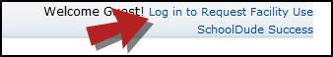
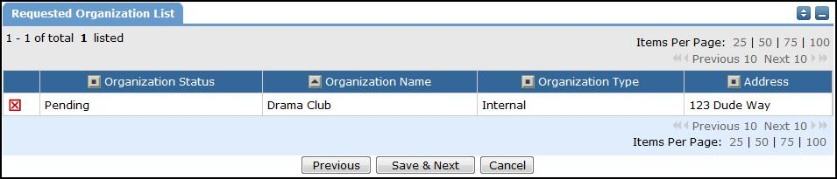

- On the Confirmation page, confirm the information and click Submit Requests.

- You should receive email confirmation that your request has been submitted. You will receive additional notifications letting you know if your request was accepted or declined.

- An email will go to the district's FSDirect Administrator who will review your request and make sure you are associated with the correct Organization(s) in their master list.

- Once your registration is accepted, you can return to the CommunityUse login page and log in to begin requesting facility usage.

